Evidence Output

T005:

Valid date of birth.

Input number 11/11/1997.

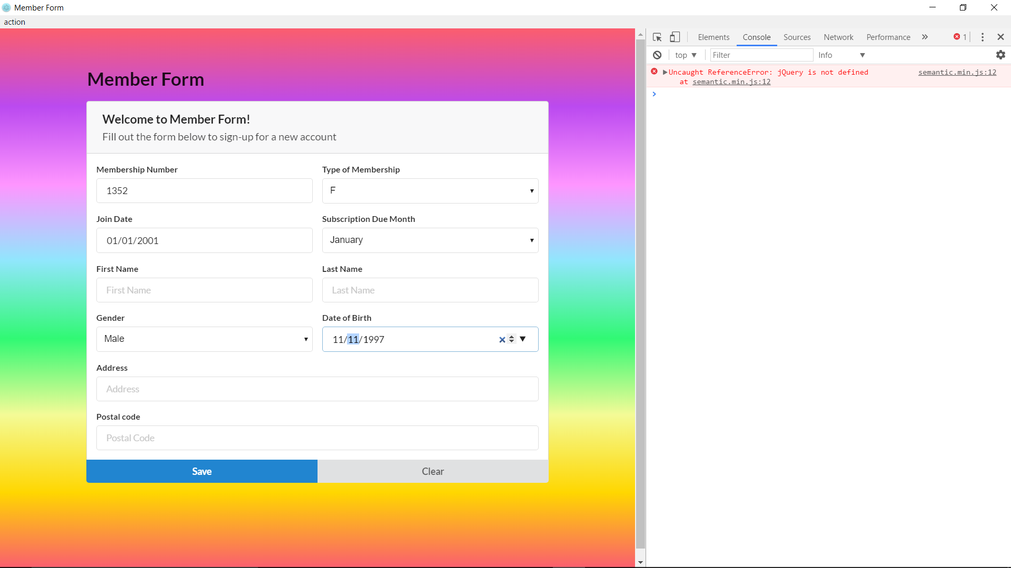

Valid date of birth success.

